***Azure Policy***

Azure Policy allows you to enforce specific rules on resources to ensure compliance with your organizational standards. To restrict resource deployments to specific regions (locations), you can use an Azure Policy definition that specifies allowed locations. Here’s how to set it up:

**Steps to Create and Assign an "Allowed Locations" Policy in Azure**

**1. **Go to Azure Policy**:**

- In the Azure Portal search for and select **Policy** from the top search bar.

**2. **Define the Policy**:**

- In the Policy pane, select **Definitions** from the left menu.

- Search for **Allowed locations** in the policy definitions. Azure provides a built-in definition named **Allowed locations** that restricts resource deployment to specified regions.

- Click on **Allowed locations** to open the policy details.

**3. **Assign the Policy**:**

- Select **Assign** from the options at the top.

- Choose the **Scope** for the policy assignment (e.g., Subscription, Resource Group). The scope defines where this policy will be enforced.

- Under **Assignment name**, provide a meaningful name like “Allowed Locations - Production Resources.”

- In the **Allowed Locations** parameter, select the specific regions (e.g., East US, West Europe) where you want to allow resources to be deployed.

**4. **Review and Create**:**

- Click **Review + create** to review your settings and assign the policy.

- Finally, click **Create** to complete the assignment.

**5. **Verify Compliance**:**

- Go to the **Compliance** section in Azure Policy to check which resources comply or don’t comply with this policy over time.

**Benefits of the "Allowed Locations" Policy**

**- **Consistency**:** Ensures that resources are deployed only in approved regions, maintaining geographic compliance.

**- **Cost Control**:** Certain regions may have higher costs; restricting locations can help control costs.

- **\*\*Data Sovereignty and Compliance**\*\*: Restricting locations ensures resources meet regulatory or organizational requirements for data residency.

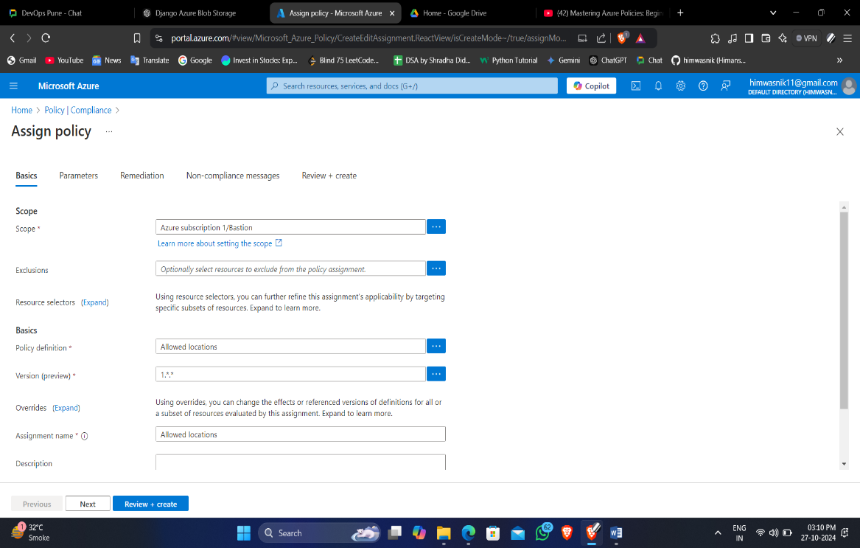

Fig. assigning policy “Allow location”

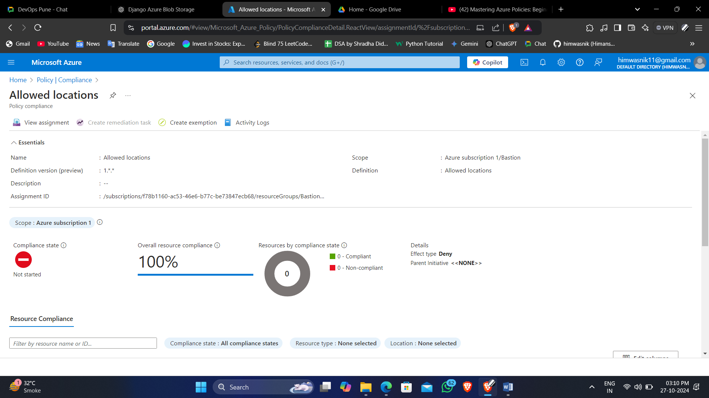

Fig. created policy

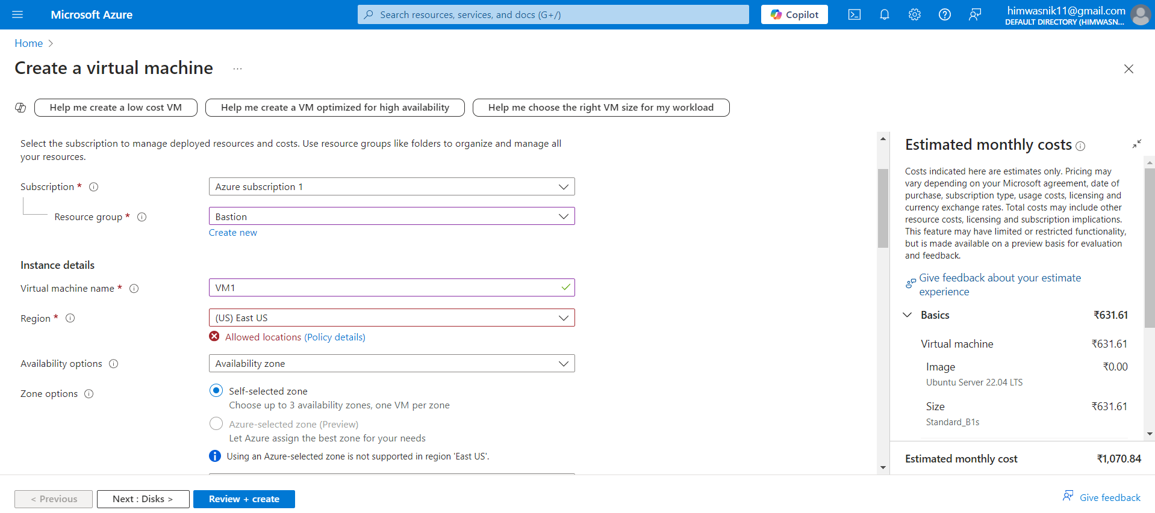

Fig. Verification not able to create using East US

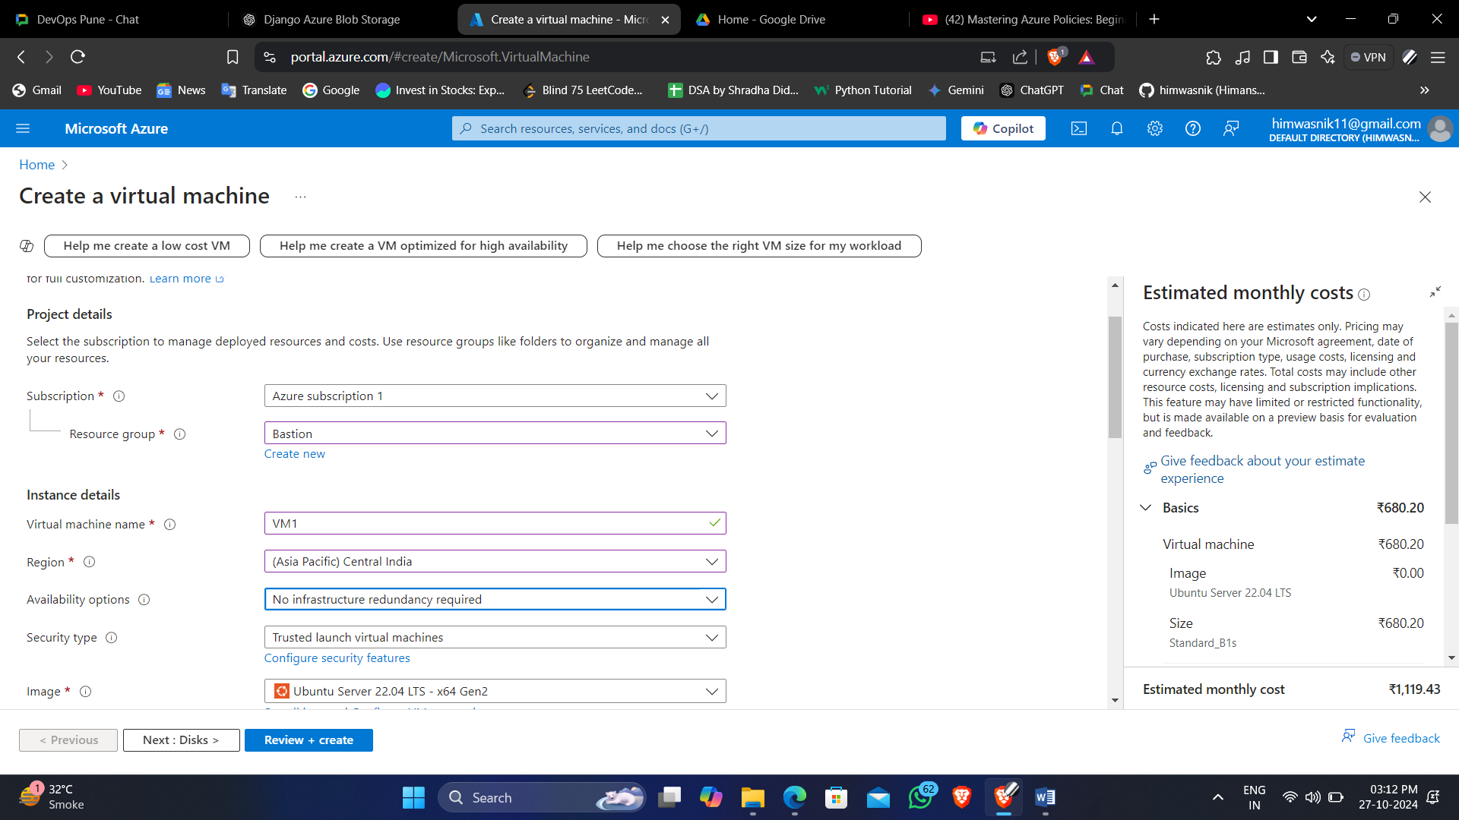

Fig. Created VM using central India region